Clean Code Principles - Be Consistent
# Source: AI Source: Provided by: [Data Path: Persons Table -> ID Column: 1, Name_En Column: Motasem Essam] -> From: [Chatgpt (GPT‑5 Mini)] on [12/9/2025]
Consistency means following the same naming, structure, formatting, and design patterns throughout your codebase.
👉 Code should look like it was written by one person, not many.

🔑 Why Consistency Matters
# Source: AI Source: Provided by: [Data Path: Persons Table -> ID Column: 1, Name_En Column: Motasem Essam] -> From: [Chatgpt (GPT‑5 Mini)] on [12/9/2025]
- Makes code easier to read and understand
- Reduces confusion for developers
- Improves teamwork and collaboration
- Speeds up development and debugging

✅ Good Example (Consistent Naming)
# Source: AI Source: Provided by: [Data Path: Persons Table -> ID Column: 1, Name_En Column: Motasem Essam] -> From: [Chatgpt (GPT‑5 Mini)] on [12/9/2025]
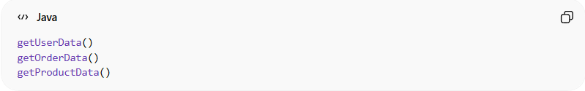
getUserData()
getOrderData()
getProductData()
👉 Same naming pattern → easy to understand

❌ Bad Example (Inconsistent Naming)
# Source: AI Source: Provided by: [Data Path: Persons Table -> ID Column: 1, Name_En Column: Motasem Essam] -> From: [Chatgpt (GPT‑5 Mini)] on [12/9/2025]
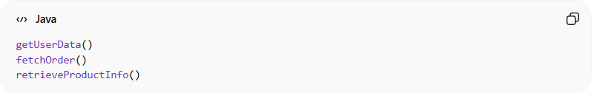
getUserData()
fetchOrder()
retrieveProductInfo()
👉 Different styles → confusing and harder to follow

🎨 Code Style Example
# Source: AI Source: Provided by: [Data Path: Persons Table -> ID Column: 1, Name_En Column: Motasem Essam] -> From: [Chatgpt (GPT‑5 Mini)] on [12/9/2025]
❌ Bad (Inconsistent Formatting)
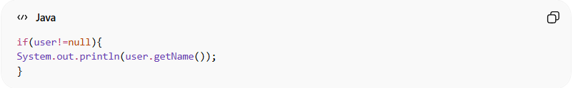
if(user!=null){
System.out.println(user.getName());
}
✅ Good (Consistent Formatting)
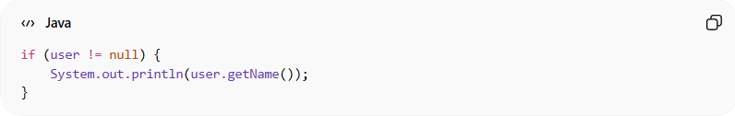
if (user != null) {
System.out.println(user.getName());
}

🧱 Structure Consistency
# Source: AI Source: Provided by: [Data Path: Persons Table -> ID Column: 1, Name_En Column: Motasem Essam] -> From: [Chatgpt (GPT‑5 Mini)] on [12/9/2025]
❌ Bad
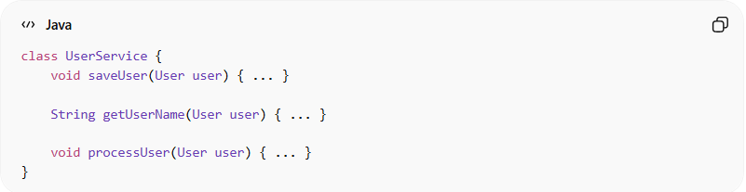
class UserService {
void saveUser(User user) { ... }

String getUserName(User user) { ... }

void processUser(User user) { ... }
}
👉 Methods are unordered and inconsistent

✅ Good
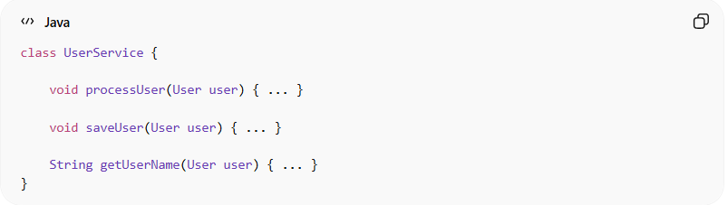
class UserService {

void processUser(User user) { ... }

void saveUser(User user) { ... }

String getUserName(User user) { ... }
}
👉 Logical and consistent ordering

🧭 Where Consistency Should Be Applied
# Source: AI Source: Provided by: [Data Path: Persons Table -> ID Column: 1, Name_En Column: Motasem Essam] -> From: [Chatgpt (GPT‑5 Mini)] on [12/9/2025]
- Naming (variables, functions, classes)
- File and folder structure
- Code formatting (indentation, spacing)
- Design patterns and architecture
- Error handling and logging

💡 Key Idea
# Source: AI Source: Provided by: [Data Path: Persons Table -> ID Column: 1, Name_En Column: Motasem Essam] -> From: [Chatgpt (GPT‑5 Mini)] on [12/9/2025]
Don’t mix styles—pick one clear approach and stick to it everywhere.

🚫 Common Mistakes
# Source: AI Source: Provided by: [Data Path: Persons Table -> ID Column: 1, Name_En Column: Motasem Essam] -> From: [Chatgpt (GPT‑5 Mini)] on [12/9/2025]
- Mixing naming styles (getUser vs fetchUser)
- Inconsistent formatting
- Different coding styles across files
- Ignoring team conventions

🧾 Summary
# Source: AI Source: Provided by: [Data Path: Persons Table -> ID Column: 1, Name_En Column: Motasem Essam] -> From: [Chatgpt (GPT‑5 Mini)] on [12/9/2025]
Consistency helps you:
- Write predictable and readable code
- Reduce mental effort when reading code
- Improve collaboration in teams
- Maintain a professional codebase

